

Project Title

OBMs-Online Bus Management system

By:

**Muhammad Owais Mushtaq**

**[18k-1177] 8E**

Hosting URL:

http://obms.atwebpages.com/

Date:

**May 23, 2022**

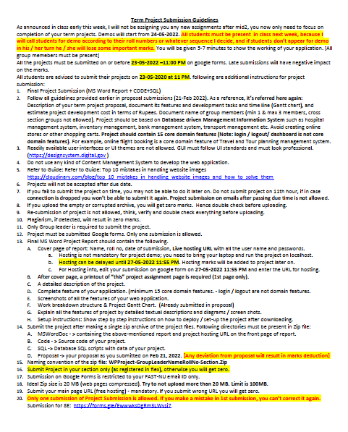

**ACKNOWLEDGEMENT**

It is indeed with a great pleasure and immense sense of gratitude that we acknowledge the help of these individuals. We are highly indebted to our Director **Dr. Muhammad Atif Tahir,** FAST-National University of Computer and Emerging Sciences, for the facilities provided to accomplish this main project.

We would like to thank our **Dr. Zulfiqar Ali Memon**, Head of the Department of Computer Science, FAST-National University of Computer and Emerging Sciences, for this constructive criticism throughout our project.

We feel elated in manifesting our sense of gratitude tour internal project guide **Mr. Abdul Rahman, Lecturer, Department of Computer Science**, FAST-National University of Computer and Emerging Sciences. She has been a constant source of inspiration for us and we are very deeply thankful to him for his support and valuable advice.

We extremely grateful to our Departmental staff members, Lab technicians and Non-teaching staff members for their extreme help throughout our project.

**Project Associate:**

Muhammad Owais Mushtaq (18K-1177)

**DECLARATION**

We hereby declare that project titled **“OBMS- Online Bus Management System”** is an original record done by us at **FAST-NUCES,** towards the partial fulfillment of requirement for the award of degree of Bachelor of Computer Science during the period of 2018-2022 in **FAST-NUCES**, and also we state that this project has not been submitted anywhere in the partial fulfillment for any degree of this or any other University.

Muhammad Owais Mushtaq (18K-1177)

**ABSTRACT**

The purpose of the project entitled as “**OBMS - Online Bus Management System**” is to computerize the Bus Management System for Adda Managers via developing Web based software which is user friendly simple, fast, and cost effective. It allows Manager to not only remotely access to all the details of bus but access for insertion, alteration, and deletion of any specific details related to bus service such as inserting the details of new bus, route, stop, or deriver etc. Traditionally, it was done manually. Which was not only very time consuming, but also very difficult in case of how to show to updated details to customers (passengers). Hence, we have given an access for passenger too, which helps them to see all the updated details any time from anywhere. However, the main features such as add/update/delete data from the database is accessible only to its administrators. Only they can add/update/delete data from the database. The data can be retrieved easily. The data are well protected for personal use and makes the data processing very fast.

**INDEX**

1. INTRODUCTION

1.1 Introduction

1.2 Problem introduction

1.3 Scope of the Project

1.4 Modules in the project

2. REQUIREMENTS SPECIFICATION

2.1 Introduction

2.2 Hardware requirements

2.3 Software requirements

2.4 Functional Requirements

2.5 Non-functional Requirements

3. Software specification

4. Gantt Chart

5. Hosting Steps

6. CONCLUSION

CHAPTER 1

**INTRODUCTION**

**1.1 Introduction:**

The purpose of the project entitled as “**OBMS - Online Bus Management System**” is to computerize the Bus Management System for Adda Managers via developing Web based software which is user friendly simple, fast, and cost effective. It allows Manager to not only remotely access to all the details of bus but access for insertion, alteration, and deletion of any specific details related to bus service such as inserting the details of new bus, route, stop, or deriver etc. Traditionally, it was done manually. Which was not only very time consuming, but also very difficult in case of how to show to updated details to customers (passengers). Hence, we have given an access for passenger too, which helps them to see all the updated details anytime from anywhere. However, the main features such as add/update/delete data from the database is accessible only to its administrators. Only they can add/update/delete data from the database. The data can be retrieved easily. The data are well protected for personal use and makes the data processing very fast. Online Bus Management System is winning over the traditional management methods due to its efficiency.

**1.2 Problem Introduction:**

**Lack of immediate retrievals: -**

The information is very difficult to retrieve and to find particular information like- E.g. - To find out about the Driver’s history, the user has to go through various registers. This results inconvenience and wastage of time.

**Lack of immediate information storage: -**

The information generated by various transactions takes time and efforts to be stored at right place.

**Lack of prompt updating: -**

Various changes to information like Bus’s details or stop details are difficult to make as paper work is involved while have to update passengers as well.

**Preparation of accurate and prompt reports: -**

This becomes a difficult task as information is difficult to collect from various register.

**1.3 Scope of the Project:**

This project can further expand in future by giving more control to passengers such as booking ticket, cancelling ticket, online payment methods etc. Plus, we could give an access to driver’s community too, so that they can ensure their departure and other important details.

**1.4 MODULES:**

The main modules of our site are:

* Admin module
* Bus module
* Driver module
* Route module
* Stop module

CHAPTER 2

**REQUIREMENT SPECIFICATION**

**2.1 INTRODUCTION:**

To be used efficiently, all computer software needs certain hardware components or the other software resources to be present on a computer. These pre-requisites are known as (computer) system requirements and are often used as a guideline rather than an absolute rule. Most software defines two sets of system requirements: minimum and recommended. With increasing demand for higher processing power and resources in newer versions of software, system requirements tend to increase over time. Industry analysts suggest that this trend plays a bigger part in driving upgrades to existing computer systems than technological advancements.

**2.2 HARDWARE REQUIREMENTS:**

The most common set of requirements defined by any operating system or software application is the physical computer resources, also known as hardware. A hardware requirements list is often accompanied by a hardware compatibility list (HCL), especially in case of operating systems. An HCL lists tested, compatibility and sometimes incompatible hardware devices for a particular operating system or application. The following sub-sections discuss the various aspects of hardware requirements.

**NORMAL HARDWARE REQUIREMENTS FOR PRESENT PROJECT:**

PROCESSOR : Intel dual Corei3

RAM : 1 GB

HARD DISK : 80 GB

**2.3 SOFTWARE REQUIREMENTS:**

Software Requirements deal with defining software resource requirements and pre-requisites that need to be installed on a computer to provide optimal functioning of an application. These requirements or pre-requisites are generally not included in the software installation package and need to be installed separately before the software is installed.

**2.4 Functional Requirements:**

Statements of services the system should provide and how the system should react to particular inputs and in particular situations. May state what the system should not do.

**Functional Requirements**

Our System has following functional requirements:

* Registration
* Login
* Insert details
* Update details
* Delete details
* Observe Changes
* Forgot Password
* Logout

**2.5 Non-Functional Requirements:**

Non-Functional Requirements specifies the quality attribute of a software system. They judge the software system based on Usability, Security, Localization, Responsiveness, Portability, Compatibility and other non-functional standards that are critical to the success of the software system.

**Non-Functional Requirements**

Our System has following non-functional requirements:

* Security requirements
* Database connectivity
* User friendly GUI of website
* Email confirmation
* Performance (e.g. website loading time, rent calculation, availability etc.)

**3. SOFTWARE SPECIFICATION**

OPERATING SYSTEM : Windows 7/8/10, Linux

FRONT END : HTML5, CSS3, Bootstrap, JavaScript

SERVER SIDE SCRIPT : PHP

DATABASE : MySQL

**4. Gantt Chart**

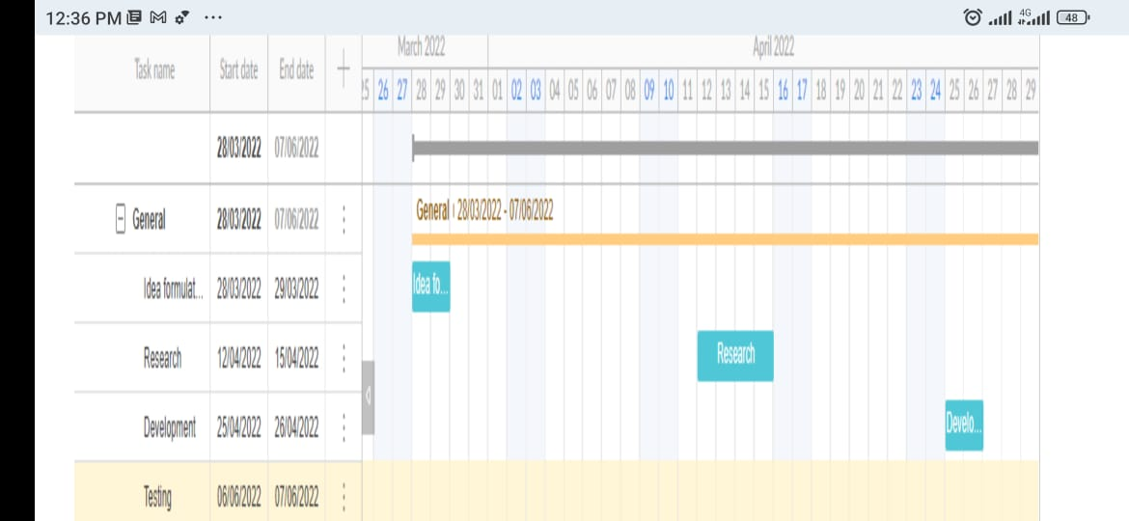

**5. Hosting Steps**

1. Log in atwebpages.com
2. Choose file manger and upload your code files
3. Then choose PHP My admin, export your sql file.
4. Select domain name and get the link of your site.

**6. Screenshots**

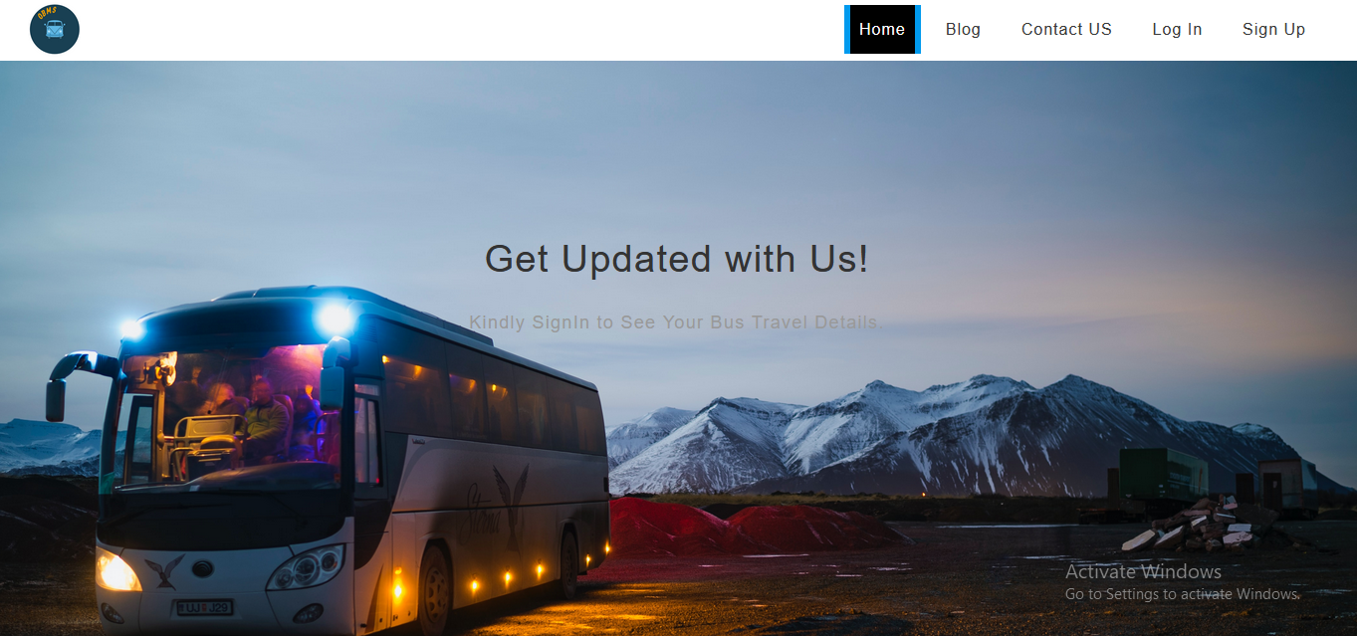

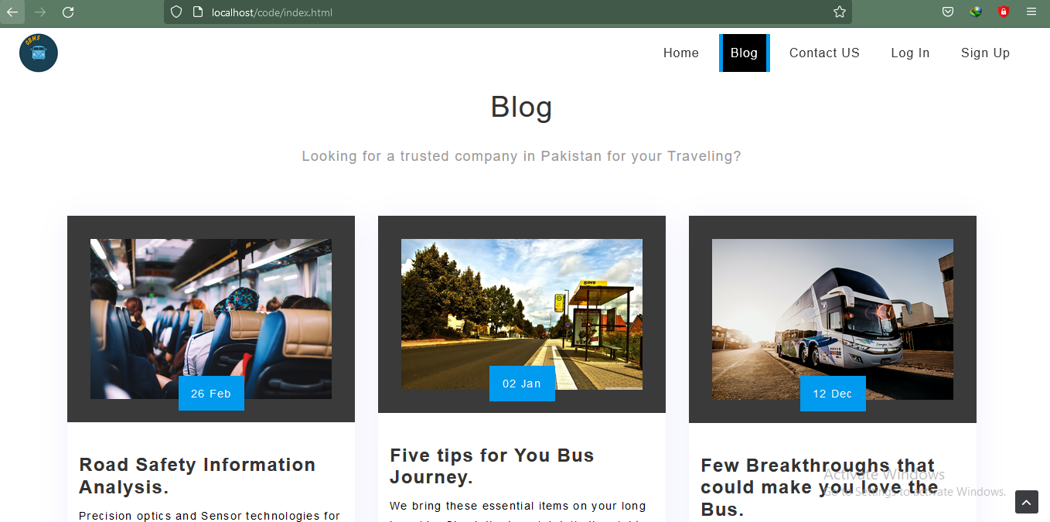

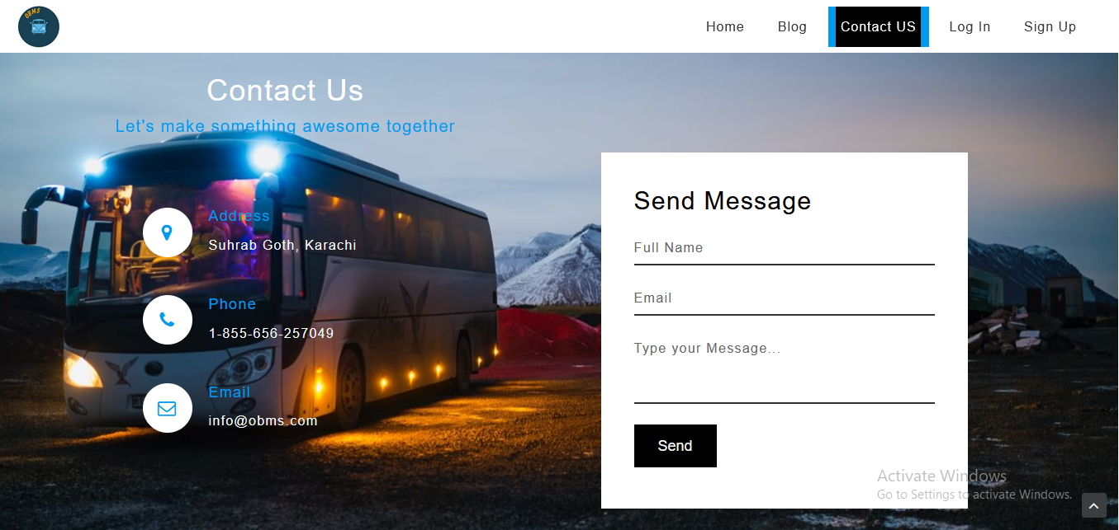

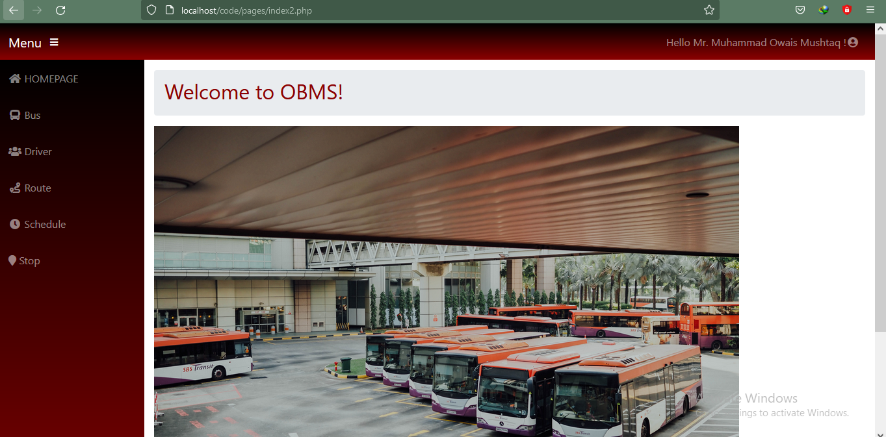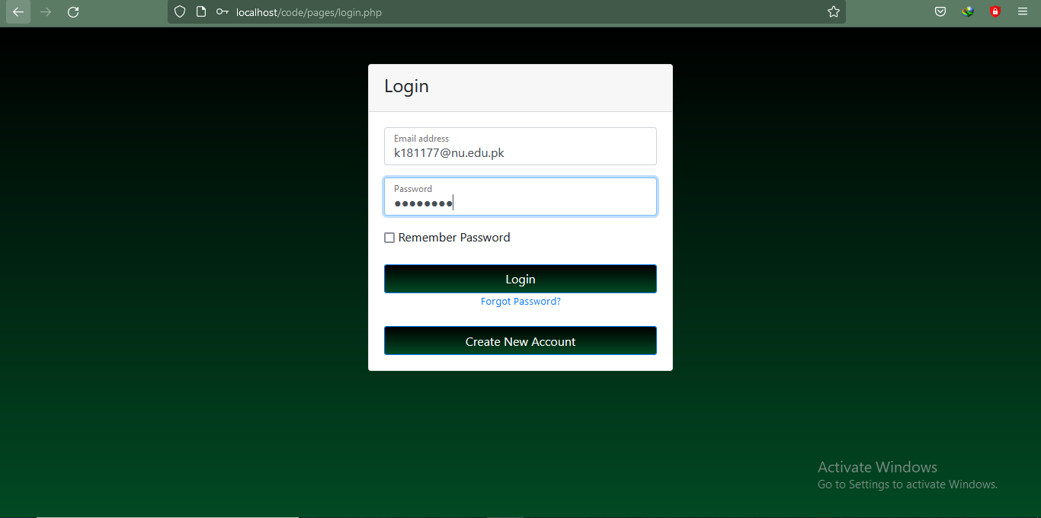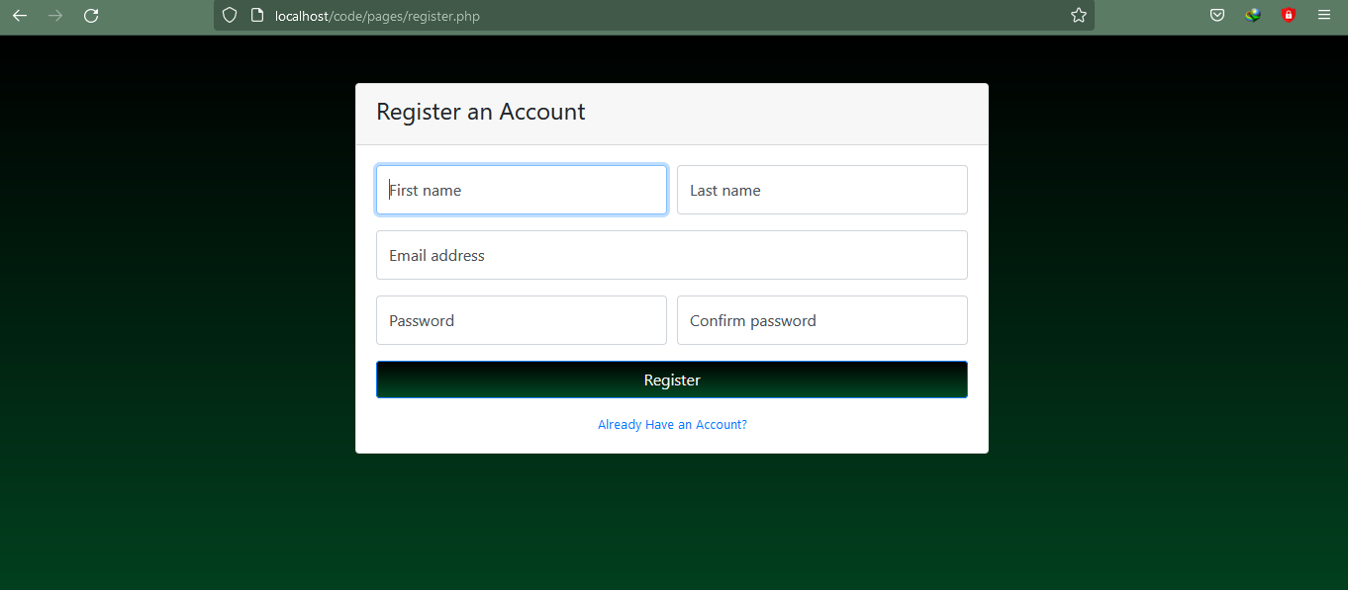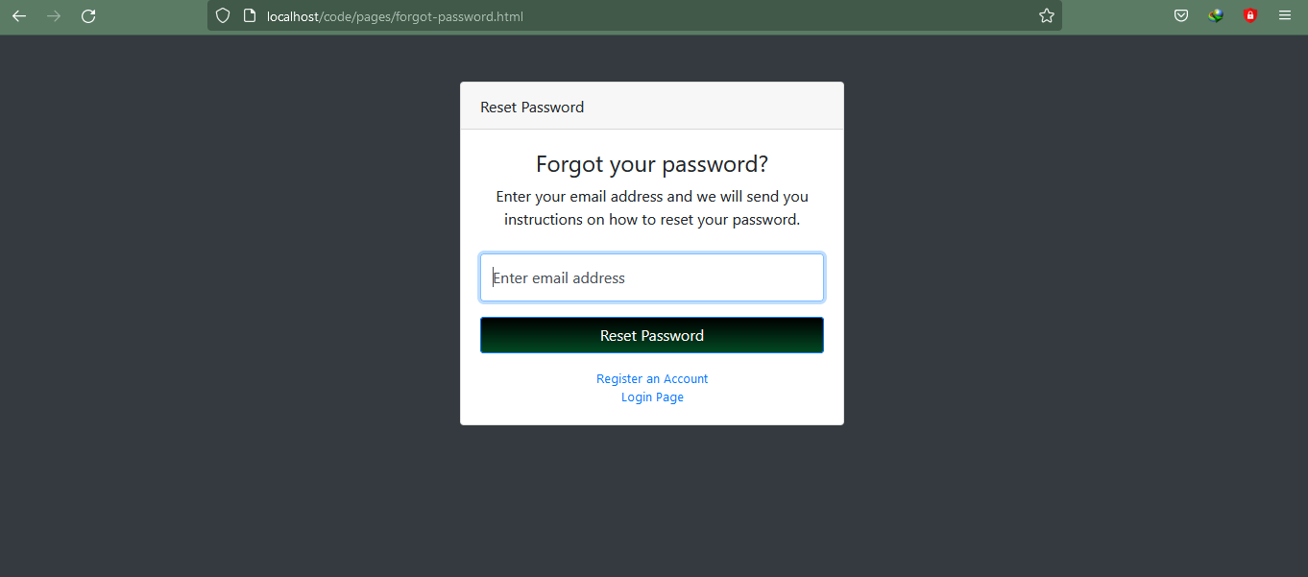 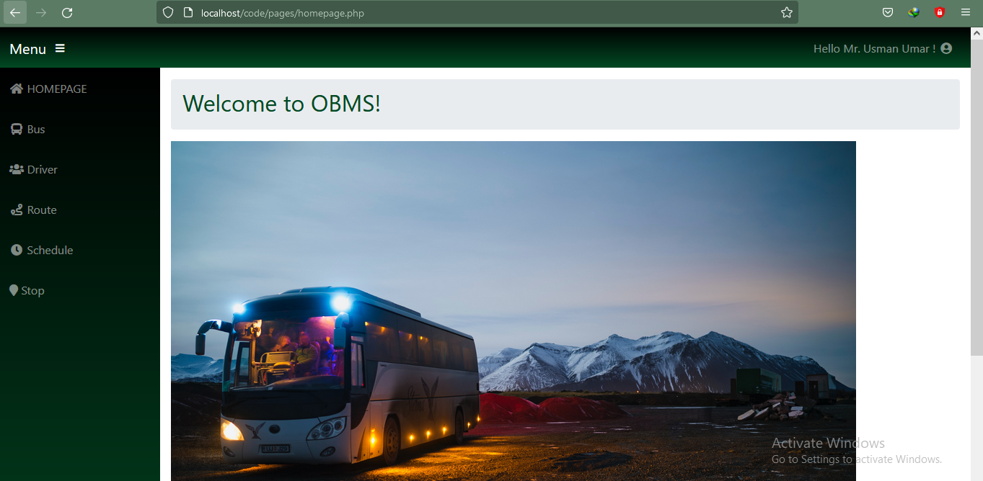

**Conclusion**

We have used implemented different techniques learn through Web Programming and computerized the Bus Management System for Adda Managers via developing Web based software which is user friendly simple, fast, and cost effective. It not only allows Manager remotely access to all the details of bus but also gives the rights for insertion, alteration, and deletion of any specific details related to bus service such as inserting the details of new bus, route, stop, or deriver etc. However, the main features such as add/update/delete data from the database is accessible only to its administrators and passengers can only see the relent details to their booking. The data can be retrieved easily. The data are well protected for personal use and makes the data processing very fast. Online Bus Management System is winning over the traditional management methods due to its efficiency.